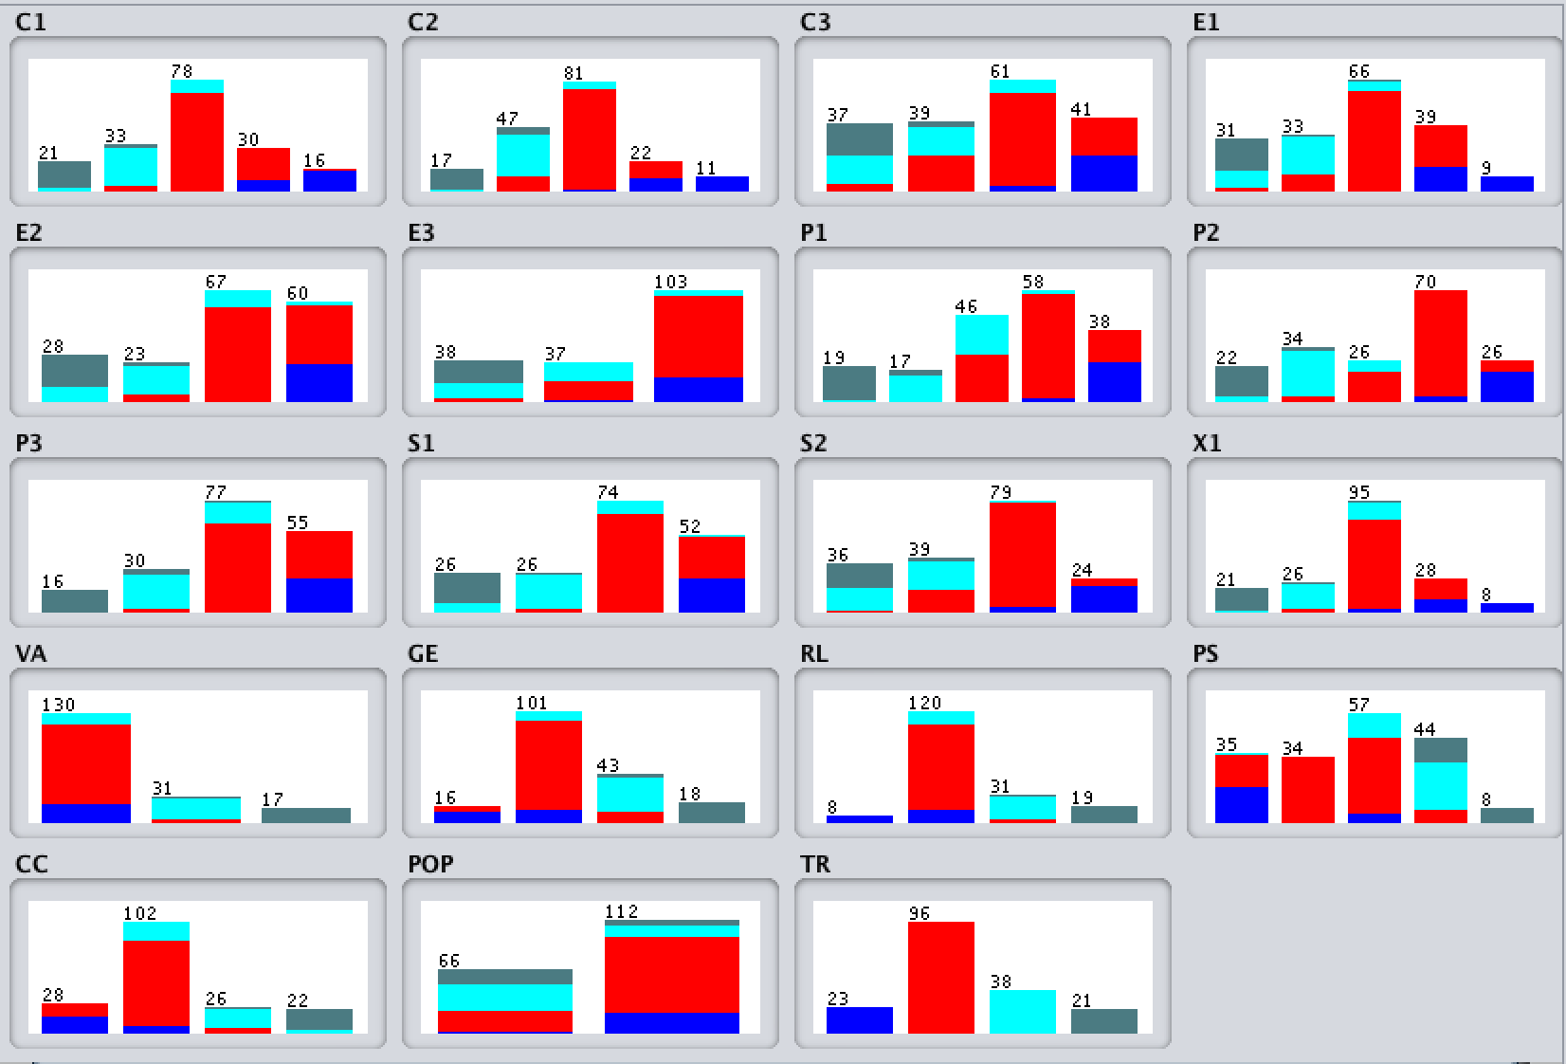

=== Run information ===

Scheme: weka.classifiers.trees.RandomForest -P 100 -I 100 -num-slots 1 -K 0 -M 1.0 -V 0.001 -S 1

Relation: Dataset 2012_x_modified-weka.filters.supervised.attribute.Discretize-Rfirst-last-precision6-weka.filters.unsupervised.attribute.Remove-R1-2

Instances: 178

Attributes: 19

C1

C2

C3

E1

E2

E3

P1

P2

P3

S1

S2

X1

VA

GE

RL

PS

CC

POP

TR

Test mode: 10-fold cross-validation

=== Classifier model (full training set) ===

RandomForest

Bagging with 100 iterations and base learner

weka.classifiers.trees.RandomTree -K 0 -M 1.0 -V 0.001 -S 1 -do-not-check-capabilities

Time taken to build model: 0.03 seconds

=== Stratified cross-validation ===

=== Summary ===

Correctly Classified Instances 170 95.5056 %

Incorrectly Classified Instances 8 4.4944 %

Kappa statistic 0.9287

Mean absolute error 0.0659

Root mean squared error 0.1446

Relative absolute error 20.71 %

Root relative squared error 36.3286 %

Total Number of Instances 178

=== Detailed Accuracy By Class ===

TP Rate FP Rate Precision Recall F-Measure MCC ROC Area PRC Area Class

0.957 0.000 1.000 0.957 0.978 0.975 1.000 1.000 Alert

0.990 0.024 0.979 0.990 0.984 0.966 0.999 0.999 Warning

0.921 0.029 0.897 0.921 0.909 0.884 0.994 0.980 Stable

0.857 0.013 0.900 0.857 0.878 0.863 0.998 0.984 Sustainable

Weighted Avg. 0.955 0.021 0.955 0.955 0.955 0.938 0.998 0.993

=== Confusion Matrix ===

a b c d <-- classified as

22 1 0 0 | a = Alert

0 95 1 0 | b = Warning

0 1 35 2 | c = Stable

0 0 3 18 | d = Sustainable

=== Run information ===

Scheme: weka.classifiers.trees.RandomTree -K 0 -M 1.0 -V 0.001 -S 1

Relation: Dataset 2012_x_modified-weka.filters.supervised.attribute.Discretize-Rfirst-last-precision6-weka.filters.unsupervised.attribute.Remove-R1-2

Instances: 178

Attributes: 19

C1

C2

C3

E1

E2

E3

P1

P2

P3

S1

S2

X1

VA

GE

RL

PS

CC

POP

TR

Test mode: 10-fold cross-validation

=== Classifier model (full training set) ===

RandomTree

==========

C1 = '(-inf-2.55]'

| P1 = '(-inf-2.45]' : Sustainable (16/0)

| P1 = '(2.45-4.35]'

| | E1 = '(-inf-3.95]'

| | | E3 = '(-inf-3.85]' : Sustainable (2/0)

| | | E3 = '(3.85-5.35]' : Stable (1/0)

| | | E3 = '(5.35-inf)' : Alert (0/0)

| | E1 = '(3.95-5.35]' : Stable (2/0)

| | E1 = '(5.35-7.15]' : Alert (0/0)

| | E1 = '(7.15-8.65]' : Alert (0/0)

| | E1 = '(8.65-inf)' : Alert (0/0)

| P1 = '(4.35-6.55]' : Alert (0/0)

| P1 = '(6.55-8.25]' : Alert (0/0)

| P1 = '(8.25-inf)' : Alert (0/0)

C1 = '(2.55-4.95]'

| P2 = '(-inf-2.65]'

| | P1 = '(-inf-2.45]' : Sustainable (2/0)

| | P1 = '(2.45-4.35]'

| | | E3 = '(-inf-3.85]' : Sustainable (1/0)

| | | E3 = '(3.85-5.35]' : Stable (1/0)

| | | E3 = '(5.35-inf)' : Alert (0/0)

| | P1 = '(4.35-6.55]' : Stable (1/0)

| | P1 = '(6.55-8.25]' : Alert (0/0)

| | P1 = '(8.25-inf)' : Alert (0/0)

| P2 = '(2.65-4.55]'

| | S1 = '(-inf-3.4]' : Stable (3/0)

| | S1 = '(3.4-4.95]' : Stable (19/0)

| | S1 = '(4.95-7.85]'

| | | C3 = '(-inf-4.15]' : Alert (0/0)

| | | C3 = '(4.15-5.65]' : Stable (1/0)

| | | C3 = '(5.65-7.65]' : Warning (1/0)

| | | C3 = '(7.65-inf)' : Alert (0/0)

| | S1 = '(7.85-inf)' : Alert (0/0)

| P2 = '(4.55-5.65]' : Stable (1/0)

| P2 = '(5.65-8.35]' : Warning (3/0)

| P2 = '(8.35-inf)' : Alert (0/0)

C1 = '(4.95-7.35]'

| GE = '(-inf--1.26292]' : Warning (1/0)

| GE = '(-1.26292-0.119325]'

| | S2 = '(-inf-2.75]' : Warning (2/0)

| | S2 = '(2.75-4.25]'

| | | C3 = '(-inf-4.15]' : Stable (1/0)

| | | C3 = '(4.15-5.65]' : Warning (5/0)

| | | C3 = '(5.65-7.65]'

| | | | X1 = '(-inf-2.65]' : Alert (0/0)

| | | | X1 = '(2.65-4.65]' : Stable (1/0)

| | | | X1 = '(4.65-7.75]' : Warning (6/0)

| | | | X1 = '(7.75-9.35]' : Alert (0/0)

| | | | X1 = '(9.35-inf)' : Alert (0/0)

| | | C3 = '(7.65-inf)' : Alert (0/0)

| | S2 = '(4.25-7.9]' : Warning (48/0)

| | S2 = '(7.9-inf)' : Warning (2/0)

| GE = '(0.119325-1.476605]'

| | X1 = '(-inf-2.65]' : Alert (0/0)

| | X1 = '(2.65-4.65]' : Stable (4/0)

| | X1 = '(4.65-7.75]'

| | | P1 = '(-inf-2.45]' : Alert (0/0)

| | | P1 = '(2.45-4.35]' : Alert (0/0)

| | | P1 = '(4.35-6.55]'

| | | | S2 = '(-inf-2.75]' : Alert (0/0)

| | | | S2 = '(2.75-4.25]' : Stable (2/0)

| | | | S2 = '(4.25-7.9]' : Warning (4/0)

| | | | S2 = '(7.9-inf)' : Alert (0/0)

| | | P1 = '(6.55-8.25]' : Stable (1/0)

| | | P1 = '(8.25-inf)' : Alert (0/0)

| | X1 = '(7.75-9.35]' : Warning (1/0)

| | X1 = '(9.35-inf)' : Alert (0/0)

| GE = '(1.476605-inf)' : Alert (0/0)

C1 = '(7.35-8.6]'

| P2 = '(-inf-2.65]' : Alert (0/0)

| P2 = '(2.65-4.55]' : Alert (0/0)

| P2 = '(4.55-5.65]' : Warning (5/0)

| P2 = '(5.65-8.35]'

| | CC = '(-inf--0.97126]'

| | | E1 = '(-inf-3.95]' : Alert (0/0)

| | | E1 = '(3.95-5.35]' : Warning (1/0)

| | | E1 = '(5.35-7.15]' : Warning (2/0)

| | | E1 = '(7.15-8.65]' : Alert (1/0)

| | | E1 = '(8.65-inf)' : Alert (0/0)

| | CC = '(-0.97126-0.241545]' : Warning (12/0)

| | CC = '(0.241545-1.372605]' : Warning (1/0)

| | CC = '(1.372605-inf)' : Alert (0/0)

| P2 = '(8.35-inf)'

| | P3 = '(-inf-2.35]' : Alert (0/0)

| | P3 = '(2.35-4.3]' : Alert (0/0)

| | P3 = '(4.3-7.35]' : Warning (1/0)

| | P3 = '(7.35-inf)' : Alert (7/0)

C1 = '(8.6-inf)'

| C2 = '(-inf-2.45]' : Alert (0/0)

| C2 = '(2.45-5.65]' : Alert (0/0)

| C2 = '(5.65-8.5]' : Warning (1/0)

| C2 = '(8.5-9.35]' : Alert (4/0)

| C2 = '(9.35-inf)' : Alert (11/0)

Size of the tree : 94

Time taken to build model: 0 seconds

=== Stratified cross-validation ===

=== Summary ===

Correctly Classified Instances 153 85.9551 %

Incorrectly Classified Instances 25 14.0449 %

Kappa statistic 0.7803

Mean absolute error 0.0669

Root mean squared error 0.2534

Relative absolute error 21.0232 %

Root relative squared error 63.684 %

Total Number of Instances 178

=== Detailed Accuracy By Class ===

TP Rate FP Rate Precision Recall F-Measure MCC ROC Area PRC Area Class

0.870 0.032 0.800 0.870 0.833 0.808 0.961 0.772 Alert

0.896 0.098 0.915 0.896 0.905 0.797 0.920 0.907 Warning

0.737 0.050 0.800 0.737 0.767 0.708 0.861 0.697 Stable

0.905 0.032 0.792 0.905 0.844 0.824 0.936 0.728 Sustainable

Weighted Avg. 0.860 0.071 0.861 0.860 0.859 0.783 0.914 0.823

=== Confusion Matrix ===

a b c d <-- classified as

20 3 0 0 | a = Alert

5 86 5 0 | b = Warning

0 5 28 5 | c = Stable

0 0 2 19 | d = Sustainable

=== Run information ===

Scheme: weka.classifiers.trees.J48 -C 0.25 -M 2

Relation: Dataset 2012_x_modified-weka.filters.supervised.attribute.Discretize-Rfirst-last-precision6-weka.filters.unsupervised.attribute.Remove-R1-2

Instances: 178

Attributes: 19

C1

C2

C3

E1

E2

E3

P1

P2

P3

S1

S2

X1

VA

GE

RL

PS

CC

POP

TR

Test mode: 10-fold cross-validation

=== Classifier model (full training set) ===

J48 pruned tree

------------------

RL = '(-inf--1.40512]': Alert (8.0)

RL = '(-1.40512-0.255595]'

| C2 = '(-inf-2.45]': Warning (0.0)

| C2 = '(2.45-5.65]'

| | P2 = '(-inf-2.65]': Stable (1.0)

| | P2 = '(2.65-4.55]': Stable (6.0)

| | P2 = '(4.55-5.65]': Stable (5.0)

| | P2 = '(5.65-8.35]': Warning (9.0)

| | P2 = '(8.35-inf)': Stable (0.0)

| C2 = '(5.65-8.5]': Warning (74.0/4.0)

| C2 = '(8.5-9.35]'

| | E1 = '(-inf-3.95]': Warning (0.0)

| | E1 = '(3.95-5.35]': Warning (1.0)

| | E1 = '(5.35-7.15]': Warning (10.0)

| | E1 = '(7.15-8.65]': Alert (7.0/1.0)

| | E1 = '(8.65-inf)': Alert (2.0)

| C2 = '(9.35-inf)': Alert (5.0)

RL = '(0.255595-1.40951]'

| E2 = '(-inf-4.5]': Stable (9.0/2.0)

| E2 = '(4.5-5.75]': Stable (14.0)

| E2 = '(5.75-7.55]'

| | C1 = '(-inf-2.55]': Warning (0.0)

| | C1 = '(2.55-4.95]': Stable (2.0)

| | C1 = '(4.95-7.35]': Warning (4.0)

| | C1 = '(7.35-8.6]': Warning (0.0)

| | C1 = '(8.6-inf)': Warning (0.0)

| E2 = '(7.55-inf)': Warning (2.0/1.0)

RL = '(1.40951-inf)': Sustainable (19.0)

Number of Leaves : 23

Size of the tree : 29

Time taken to build model: 0 seconds

=== Stratified cross-validation ===

=== Summary ===

Correctly Classified Instances 150 84.2697 %

Incorrectly Classified Instances 28 15.7303 %

Kappa statistic 0.7512

Mean absolute error 0.1008

Root mean squared error 0.2691

Relative absolute error 31.6949 %

Root relative squared error 67.6287 %

Total Number of Instances 178

=== Detailed Accuracy By Class ===

TP Rate FP Rate Precision Recall F-Measure MCC ROC Area PRC Area Class

0.783 0.039 0.750 0.783 0.766 0.731 0.937 0.733 Alert

0.865 0.159 0.865 0.865 0.865 0.706 0.882 0.868 Warning

0.789 0.064 0.769 0.789 0.779 0.718 0.899 0.710 Stable

0.905 0.000 1.000 0.905 0.950 0.945 0.968 0.935 Sustainable

Weighted Avg. 0.843 0.104 0.845 0.843 0.844 0.740 0.903 0.824

=== Confusion Matrix ===

a b c d <-- classified as

18 5 0 0 | a = Alert

6 83 7 0 | b = Warning

0 8 30 0 | c = Stable

0 0 2 19 | d = Sustainable